SONNE or METEOR or MARIA S.MERIAN or ALKOR or ELISABETH MANN BORGESE or HEINCKE-Berichte

TITLE

Cruise No. M or MSM or SO or POS or AL or HE or EMBXX/Leg

DATE – DATE,
Port of Sailing (Country) – Port of Arrival (Country)
ACRONYM (Kürzel laut Antrag)

LOGO / PHOTO etc.
(only if available)

AUTHORS

Chief Scientist
Institution

20XX
Table of Contents
1 Cruise Summary 3
1.1 Summary in English 3
1.2 Zusammenfassung 3
2 Participants 3
2.1 Principal Investigators 3
2.2 Scientific Party 3
2.3 Participating Institutions 4
3 Research Program 4
3.1 Description of the Work Area 4
3.2 Aims of the Cruise 4
3.2 Agenda of the Cruise 4
4 Narrative of the Cruise 6
5 Preliminary Results 6
5.1 Underway Hydroacoustics 6
5.1.1 System Overview and Data Processing 6
5.2 Water and Plankton Sampling with CTD/Rosette 6
5.2.1 CTD Measurements and Sampling for Stable Isotopes 6
. 6
5.X Expected Results 6
6 Ship’s Meteorological Station 6
7 Station List MXX/Y 7
7.1 Overall Station List 7
7.2 Profile Station List 7
7.3 Sample Station List 7
8 Data and Sample Storage and Availability 7
9 Acknowledgements 7
10 References 8
11 Abbreviations 8
12 Appendices 8
12.1 Selected Pictures of Samples 8
12.2 Selected Pictures of Shipboard Operations 8

1 Cruise Summary

1.1 Summary in English
Lorem ipsum dolor sit amet, consectetuer adipiscing elit. Aenean commodo ligula eget dolor. Aenean massa. Cum sociis natoque penatibus et magnis dis parturient montes, nascetur ridiculus mus. Donec quam felis, ultricies nec, pellentesque eu, pretium quis, sem. Nulla consequat massa quis enim. Donec pede justo, fringilla vel, aliquet nec, vulputate eget, arcu.
In enim justo, rhoncus ut, imperdiet a, venenatis vitae, justo. Nullam dictum felis eu pede mollis pretium. Integer tincidunt. Cras dapibus. Vivamus elementum semper nisi. Aenean vulputate eleifend tellus. Aenean leo ligula, porttitor eu, consequat vitae, eleifend ac, enim.

1.2 Zusammenfassung
Lorem ipsum dolor sit amet, consectetuer adipiscing elit. Aenean commodo ligula eget dolor. Aenean massa. Cum sociis natoque penatibus et magnis dis parturient montes, nascetur ridiculus mus. Donec quam felis, ultricies nec, pellentesque eu, pretium quis, sem. Nulla consequat massa quis enim. Donec pede justo, fringilla vel, aliquet nec, vulputate eget, arcu.
In enim justo, rhoncus ut, imperdiet a, venenatis vitae, justo. Nullam dictum felis eu pede mollis pretium. Integer tincidunt. Cras dapibus. Vivamus elementum semper nisi. Aenean vulputate eleifend tellus. Aenean leo ligula, porttitor eu, consequat vitae, eleifend ac, enim.

2 Participants

2.1 Principal Investigators
Name | Institution
Meyer, Johann, Prof. | GEOMAR

2.2 Scientific Party
Name | Discipline | Institution
Meyer, Johann, Prof. | Marine Geology / Chief Scientist | GEOMAR

2.3 Participating Institutions
GEOMAR Helmholtz-Zentrum für Ozeanforschung Kiel
CAU Christian-Albrechts-Universität zu Kiel
DWD Deutscher Wetterdienst, Geschäftsfeld Seeschifffahrt
NIOZ Netherlands Institute for Sea Research

3 Research Program

3.1 Description of the Work Area
Lorem ipsum dolor sit amet, consectetuer adipiscing elit. Aenean commodo ligula eget dolor. Aenean massa. Cum sociis natoque penatibus et magnis dis parturient montes, nascetur ridiculus mus. Donec quam felis, ultricies nec, pellentesque eu, pretium quis, sem. Nulla consequat massa quis enim. Donec pede justo, fringilla vel, aliquet nec, vulputate eget, arcu.

3.2 Aims of the Cruise
Lorem ipsum dolor sit amet, consectetuer adipiscing elit. Aenean commodo ligula eget dolor. Aenean massa. Cum sociis natoque penatibus et magnis dis parturient montes, nascetur ridiculus mus. Donec quam felis, ultricies nec, pellentesque eu, pretium quis, sem. Nulla consequat massa quis enim. Donec pede justo, fringilla vel, aliquet nec, vulputate eget, arcu.

3.3 Agenda of the Cruise
Lorem ipsum dolor sit amet, consectetuer adipiscing elit. Aenean commodo ligula eget dolor. Aenean massa. Cum sociis natoque penatibus et magnis dis parturient montes, nascetur ridiculus mus. Donec quam felis, ultricies nec, pellentesque eu, pretium quis, sem. Nulla consequat massa quis enim. Donec pede justo, fringilla vel, aliquet nec, vulputate eget, arcu.

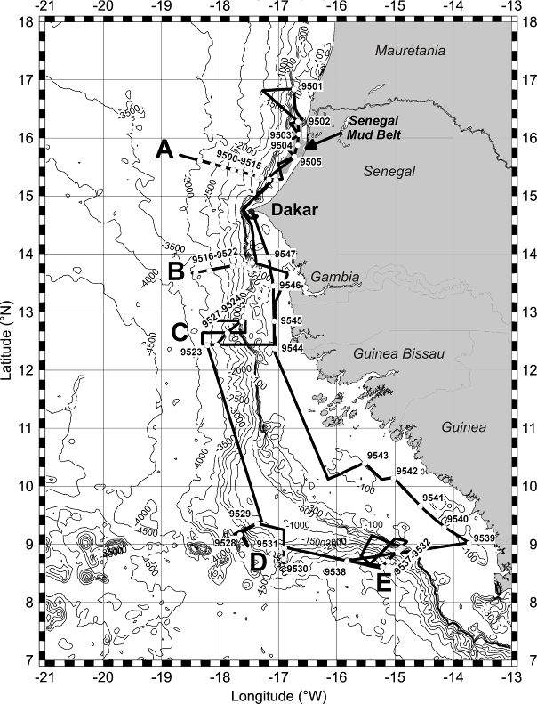
Fig. 3.1 Track chart of R/V Meteor Cruise M65/1. Bathymetry from Smith and Sandwell (1997). Six main working areas (Senegal Mudbelt and Working Areas A-E.

Lorem ipsum dolor sit amet, consectetuer adipiscing elit. Aenean commodo ligula eget dolor. Aenean massa. Cum sociis natoque penatibus et magnis dis parturient montes, nascetur ridiculus mus. Donec quam felis, ultricies nec, pellentesque eu, pretium quis, sem. Nulla consequat massa quis enim. Donec pede justo, fringilla vel, aliquet nec, vulputate eget, arcu.
In enim justo, rhoncus ut, imperdiet a, venenatis vitae, justo. Nullam dictum felis eu pede mollis pretium. Integer tincidunt. Cras dapibus. Vivamus elementum semper nisi. Aenean vulputate eleifend tellus. Aenean leo ligula, porttitor eu, consequat vitae, eleifend ac, enim.

4 Narrative of the Cruise
Lorem ipsum dolor sit amet, consectetuer adipiscing elit. Aenean commodo ligula eget dolor. Aenean massa. (…) Donec pede justo, fringilla vel, aliquet nec, vulputate eget, arcu.
In enim justo, rhoncus ut, imperdiet a, venenatis vitae, justo. (…). Aenean vulputate eleifend tellus. Aenean leo ligula, porttitor eu, consequat vitae, eleifend ac, enim.

5 Preliminary Results

5.1 Underway Hydroacoustics
(P. Winter and Shipboard Scientific Party)

5.1.1 System Overview and Data Processing
Lorem ipsum dolor sit amet, consectetuer adipiscing elit. Aenean commodo ligula eget dolor. Aenean massa. (…) Donec pede justo, fringilla vel, aliquet nec, vulputate eget, arcu.

5.2 Water and Plankton Sampling with CTD/Rosette

5.2.1 CTD Measurements and Sampling for Stable Isotopes
(D. Schulz¹, K. Meyer²)
¹GEOMAR
²IMFB
Lorem ipsum dolor sit amet, consectetuer adipiscing elit. Aenean commodo ligula eget dolor. Aenean massa. (…) Donec pede justo, fringilla vel, aliquet nec, vulputate eget, arcu.

.

5.X Expected Results (only if available)
(P. Meyer, Shipboard Scientific Party)
.

6 Ship’s Meteorological Station (only if available)
(A. Schmidt)
Lorem ipsum dolor sit amet, consectetuer adipiscing elit. Aenean commodo ligula eget dolor. Aenean massa. Cum sociis natoque penatibus et magnis dis parturient montes, nascetur ridiculus mus. Donec quam felis, ultricies nec, pellentesque eu, pretium quis, sem. Nulla consequat massa quis enim. Donec pede justo, fringilla vel, aliquet nec, vulputate eget, arcu.
In enim justo, rhoncus ut, imperdiet a, venenatis vitae, justo. Nullam dictum felis eu pede mollis pretium. Integer tincidunt. Cras dapibus. Vivamus elementum semper nisi. Aenean vulputate eleifend tellus. Aenean leo ligula, porttitor eu, consequat vitae, eleifend ac, enim.

7 Station List MXX/Y

7.1 Overall Station List
Station No. |  | Date | Gear | Time | Latitude | Longitude | Water Depth | Remarks/Recovery
METEOR | MARUM | 2005 |  | [UTC] | [°N] | [°W] | [m]
M54/3_447-1 | 9501-1 | 12.6. | ROS/CTD | 17:24 | 16°50.41’ | 16°43.96’ | 330.5 | 300-200-100-50-25-0 m
M54/3_448-2 | 9501-2 | 12.6. | ROS/CTD | 18:30 | 16°50.40’ | 16°43.93’ | 330.5 | CTD 10 m above rosette, 16 bottles, 300 m

7.2 Profile Station List (only if available)
Station No. | Profile Station No. | Date | Time | Latitude | Longitude | Max. Depth | Bottom | Profile numbers
METEOR |  | 2015 | h | [°N] | [°W] | [m] | [m]
M54/3_447-1 | 01 | 12.6. | ? | 16°50.41’ | 16°43.96’ | 140 - 186 | 3617 - 3618 | 001 - 002
M54/3_448-2 | 02 | 12.6. | ? | 16°50.40’ | 16°43.93’ | 441 - 945 | 5071 - 5079 | 003 - 027

7.3 Sample Station List (only if available)
Station No. | Sample Station No. | Date | Time | Latitude | Longitude | Water Depth | ? | ?
METEOR |  | 2015 | h | [°N] | [°W] | [m] | ?
M54/3_447-1 | 01 | 12.6. | ? | 16°50.41’ | 16°43.96’ | ? | ? | ?
M54/3_448-2 | 02 | 12.6. | ? | 16°50.40’ | 16°43.93’ | ? | ? | ?

8 Data and Sample Storage and Availability
Lorem ipsum dolor sit amet, consectetuer adipiscing elit. Aenean commodo ligula eget dolor. Aenean massa. Cum sociis natoque penatibus et magnis dis parturient montes, nascetur ridiculus mus. Donec quam felis, ultricies nec, pellentesque eu, pretium quis, sem. Nulla consequat massa quis enim. Donec pede justo, fringilla vel, aliquet nec, vulputate eget, arcu.

Table 8.1 Overview of data availability
Type | Database | Available | Free Access | Contact
hydrography |  | Date | Date | E-Mail
raw data CTD, ADCP | PANGAEA | Jan.13 | Jun.14 | ……..@.........de

9 Acknowledgements
Lorem ipsum dolor sit amet, consectetuer adipiscing elit. Aenean commodo ligula eget dolor. Aenean massa. Cum sociis natoque penatibus et magnis dis parturient montes, nascetur ridiculus mus. Donec quam felis, ultricies nec, pellentesque eu, pretium quis, sem. Nulla consequat massa quis enim. Donec pede justo, fringilla vel, aliquet nec, vulputate eget, arcu.

10 References
Sargent, J.R., 1976. The structure, metabolism and function of lipids in marine organisms. In: Malins, D.C., Sargent, J.R. (Eds.), Biochemical and Biophysical Perspectives in Marine Biology. Academic Press, London, pp. 149-212.
Smith, K.L., Ruhl, H.A., Kaufmann, R.S., Kahru, M., 2008. Tracing abyssal food supply back to upper-ocean processes over a 17-year time series in the northeast Pacific. Limnology and Oceanography 53, 2655-2667.

11 Abbreviations
Lorem ipsum dolor sit amet, consectetuer adipiscing elit. Aenean commodo ligula eget dolor.

12 Appendices

12.1 Selected Pictures of Samples

12.2 Selected Pictures of Shipboard Operations

.

